**ITRW 311**

**Chapter 2**

1. What is data modeling?

Iterative and progressive process of creating a specific data model for a determined problem domain.

1. What is a data Model?

Simple representations of complex real-world data structures, usually graphical.

* Useful for supporting a specific problem domain.

1. What is a Model?

Abstraction of a real-world object or event

1. What is the Model’s main Function?

To help you understand the complexities of the real-world environment.

1. Importance of Data Models:

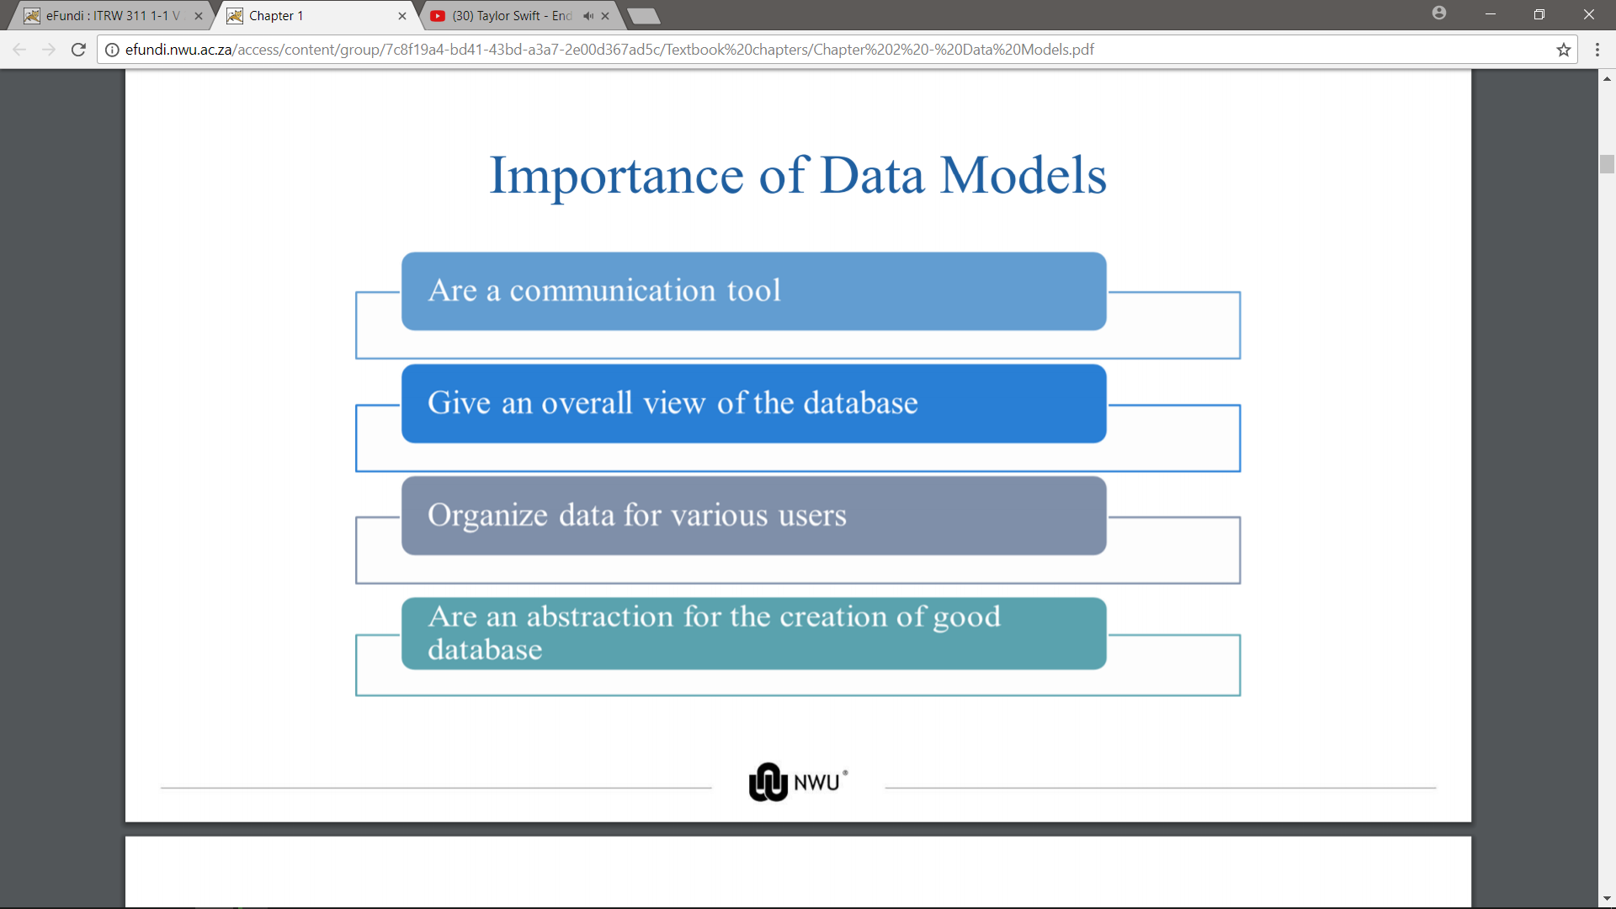

1. What are the Data Model Basic Building Blocks?

* Entity: Unique and distinct object used to collect and store data .
* Attribute: Characteristic of an entity.
* Relationship: Describes an association among entities

- One-to-many (1:M)

- Many-to-many (M:N or M:M)

- One-to-one (1:1)

* Relationships are bidirectional (↔)
* Constraint: Restrictions (rules) placed on the data to ensure data integrity.

1. Business Rules:

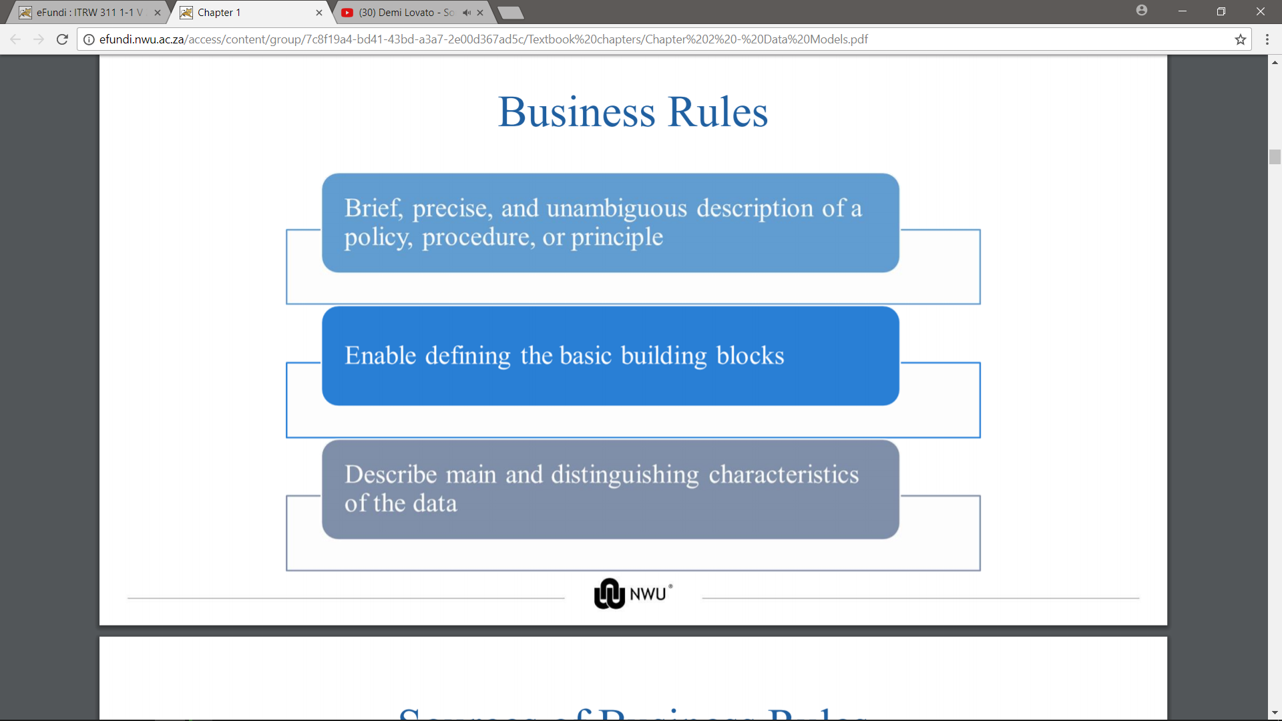

1. Sources of Business Rules:

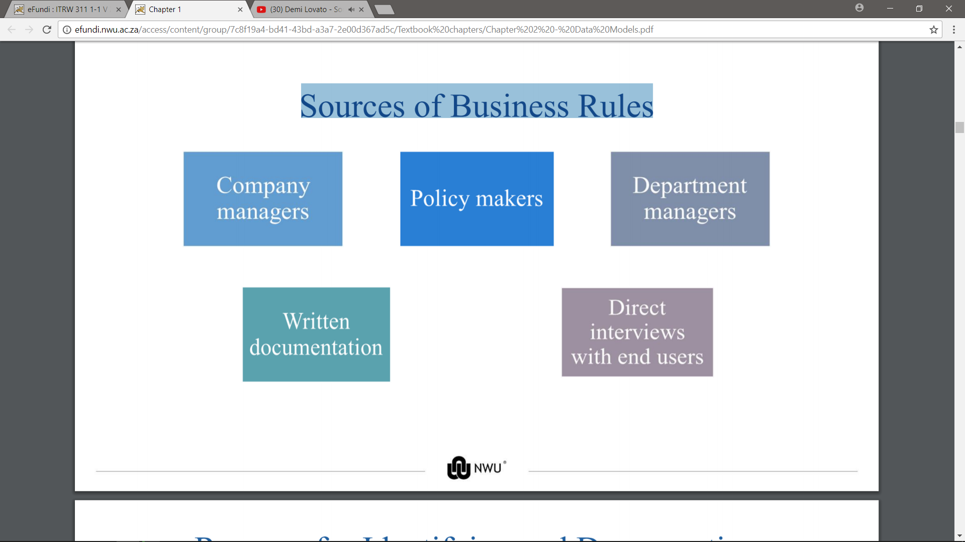

1. Reasons for Identifying and Documenting Business Rules:

* Help standardize company’s view of data
* Communications tool between users and designers
* Allow designer to:

- Understand the nature, role, scope of data, and business processes

- Develop appropriate relationship participation rules and constraints

- Create an accurate data mode

1. Translating Business Rules into Data Model Components:

* Nouns translate into entities
* Verbs translate into relationships among entities
* Relationships are bidirectional
* Questions to identify the relationship type\

- How many instances of B are related to one instance of A?

- How many instances of A are related to one instance of B?

1. What is Entity names - Required to:

* Be descriptive of the objects in the business environment
* Use terminology that is familiar to the users

1. What is Attribute name Required to?

Required to be descriptive of the data represented by the attribute.

1. What will poor naming do?

* Facilitates communication between parties
* Promotes self-documentation

1. The evolution of Data Models:

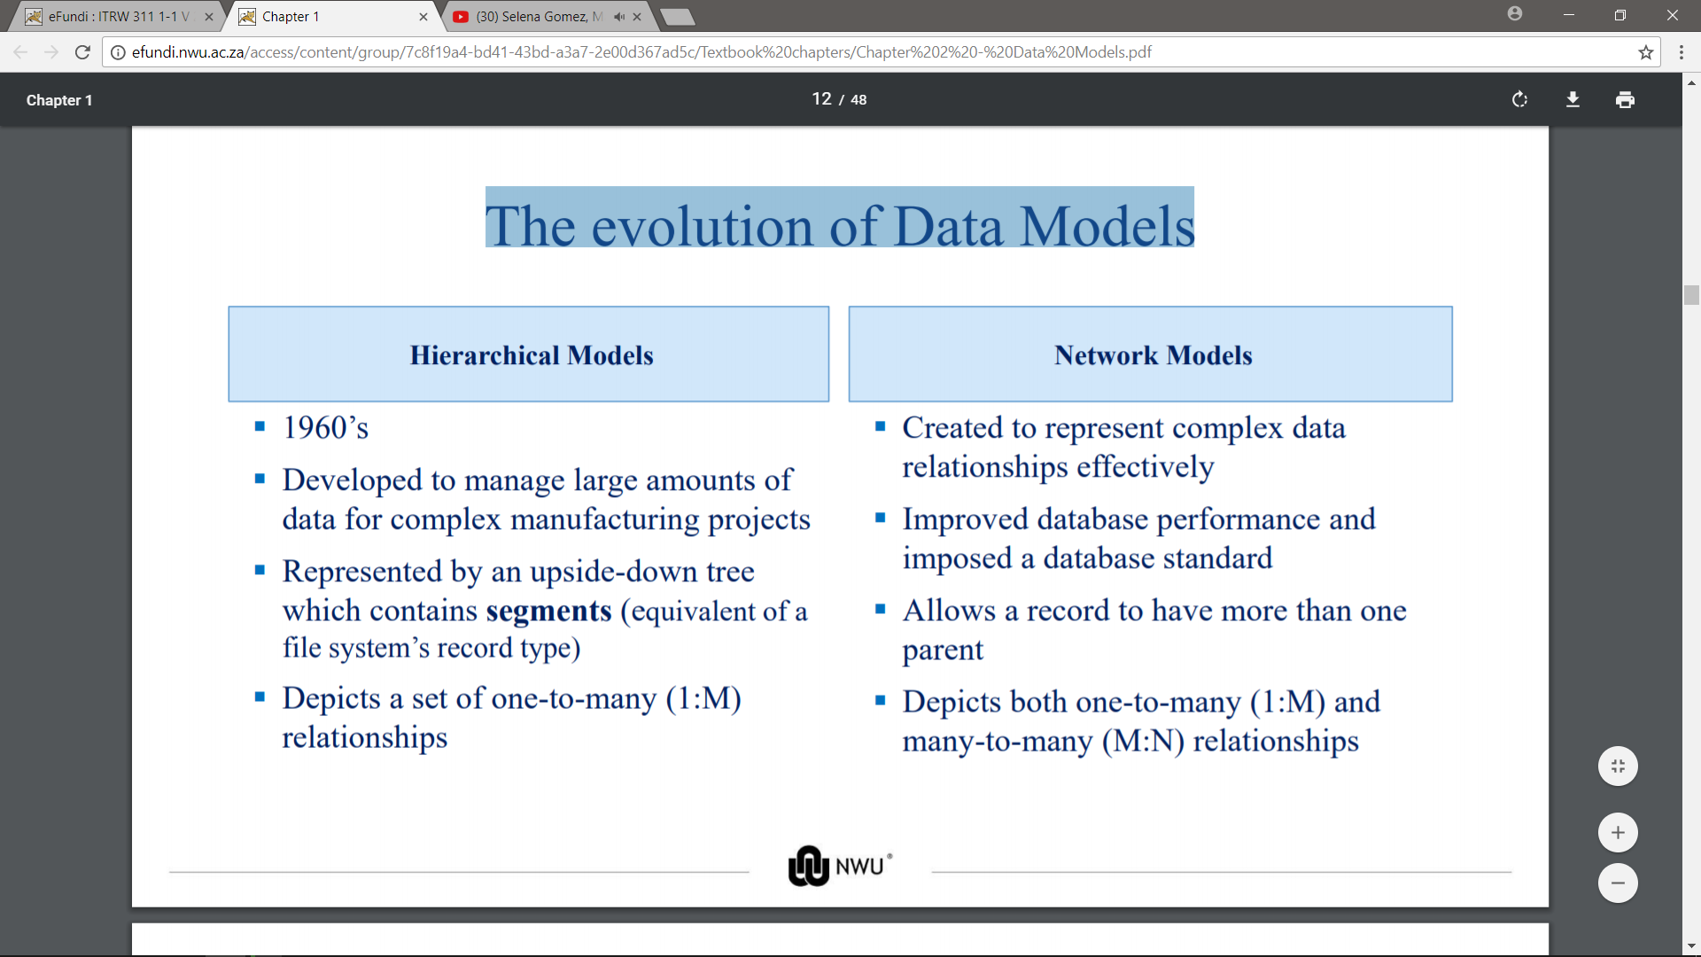

1. Standard Database Concepts:

